`Somethings about Dual Arms project
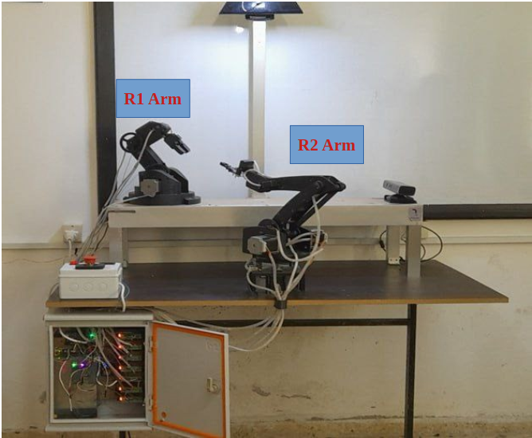

1- Arduino Pins :
Motors:
R1:
#define R1baseDir 35 //------base motor direction pin
#define R1baseStep 34 //------base motor step pin
#define R1shoulderDir 37 //------shoulder motor direction pin
#define R1shoulderStep 36 //------shoulder motor direction pin
#define R1elbowDir 39 //------arm motor direction pin
#define R1elbowStep 38 //------arm motor step pin
#define R1wristDir 41 //------arm motor direction pin
#define R1wristStep 40 //------arm motor step pin
#define R1IN1BYJ - //in1 for BYJ stepper motor for R1 wrist
#define R1IN2BYJ - //in2 for BYJ stepper motor for R1 wrist
#define R1IN3BYJ - //in3 for BYJ stepper motor for R1 wrist
#define R1IN4BYJ - //in4 for BYJ stepper motor for R1 wrist
#define R1EndEffPin 10//------End Effector for R1
R2:
#define R2baseDir 29 //------base motor direction pin
#define R2baseStep 28 //------base motor step pin
#define R2shoulderDir 31 //------shoulder motor direction pin
#define R2shoulderStep 30 //------shoulder motor direction pin
#define R2elbowDir 33 //------arm motor direction pin
#define R2elbowStep 32 //------arm motor step pin
#define R2WristPin 9 //------Servo motor pin for R2 wrist
#define R2EndEffPin 8//------End Effector for R2

_____________________________________________________________________________________________________

Limit Switches:
R2:
#define R2baseLimit A0
#define R2shoulderLimit A1
#define R2elbowLimit A2
R1:
#define R1baseLimit -
#define R1shoulderLimit A3
#define R1elbowLimit A4
_____________________________________________________________________________________________________
2- zero angles :
#define R1theta1 90
#define R1theta2 125
#define R1theta3 -97
#define R1theta4 -78
#define R2theta1 185
#define R2theta2 60
#define R2theta3 -7
#define R2theta4 160

3- Gears Transmition Values :
#define R1BaseTr 3.3
#define R1ShoulderTr 5.0
#define R1ElbowTr 3.5
#define R1WristTr 2.3
#define R2BaseTr 1
#define R2ShoulderTr 4.5
#define R2ElbowTr 4.5
_____________________________________________________________________________________________________

4- End Effectors Angles :
#define R1_openGripperAngle 180
#define R1_closeGripperAngle 0
#define R2_openGripperAngle 38
#define R2_closeGripperAngle 160

